
Clafoutis with Brie

Prep time :15 min

Cook time : 25 min

Ingredients :

-200g (7.2 oz) wheel Brie
-50 cl (17 fl oz) milk
-4 large eggs
-6 chives leaves
-40g (1.4 oz) butter
-2 pinches of curry powder
-Pepper

Preparation :

Preheat oven to 180°C (350°F) and put a dish with water to do bain-marie
Cut rind from brie and cut cheese into 1-1/2 inch cubes. Fill several porcelain bowls with cheese
Beat together eggs and milk
Salt and pepper
Add curry powder, salt, pepper and chopped chives
Fill bowls
Bake in oven (bain marie) about 25 mn to 180°C.
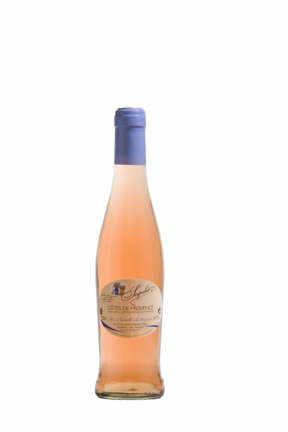

Côté de Provence, Cheverny rosé

Serve with smoked jam and small cherry tomatoes

Bon Appétit !

